--Blur Detection Using Classical Machine Learning--Abstract:
This project focuses on detecting and classifying image blur using classical machine learning techniques. The system categorizes images into three classes: sharp, defocused blur, and motion blur. Instead of deep learning, handcrafted image processing features are extracted and fed into traditional machine learning classifiers. The proposed approach achieves reliable performance with low computational cost.

Introduction:
Blur detection is an important task in image processing and computer vision, especially in photography, surveillance, and medical imaging. Blurred images reduce visual quality and affect downstream tasks. This project aims to automatically detect and classify blur types using feature-based machine learning methods.

Project Objectives:
1. Detect whether an image is sharp or blurred.
2. Distinguish between defocused blur and motion blur.
3. Use classical machine learning instead of deep learning.
4. Evaluate and compare different classifiers.

Dataset Description:
The dataset is organized into three folders: sharp, defocused blurred, and motion blurred. Each folder contains grayscale images resized to 256x256 pixels. The dataset is split into training (80%) and testing (20%) sets using stratified sampling.

System Pipeline:
1. Image acquisition and preprocessing
2. Feature extraction
3. Feature normalization
4. Machine learning model training
5. Model evaluation and visualization

Feature Extraction:
Four handcrafted features are extracted from each image:
- Variance of Laplacian: Measures image focus and edge sharpness.
- Sobel Edge Strength: Captures edge intensity and gradient magnitude.
- FFT High-Frequency Energy: Detects motion blur by analyzing frequency components.
- Image Entropy: Measures texture and information content.

Machine Learning Models:
Two classifiers are used:
1. Support Vector Machine (SVM) with RBF kernel and feature scaling.
2. Random Forest Classifier with 300 decision trees.
SVM is used as the primary model while Random Forest serves as a comparison baseline.

Evaluation Metrics:
Model performance is evaluated using:
- Accuracy
- Precision, Recall, and F1-score
- Confusion Matrix for class-wise analysis
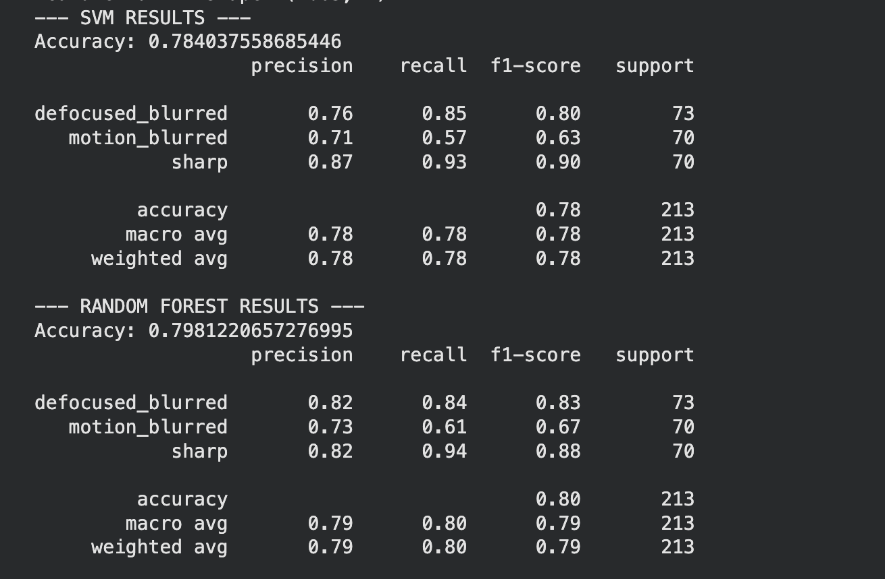
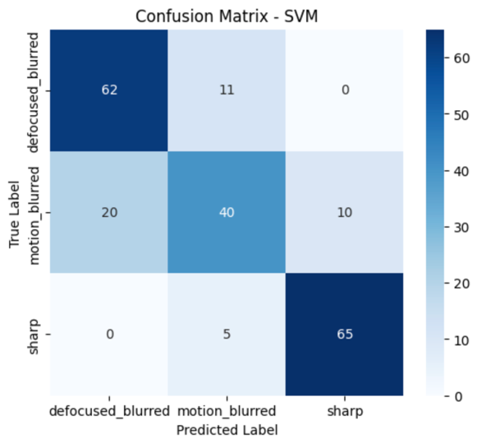 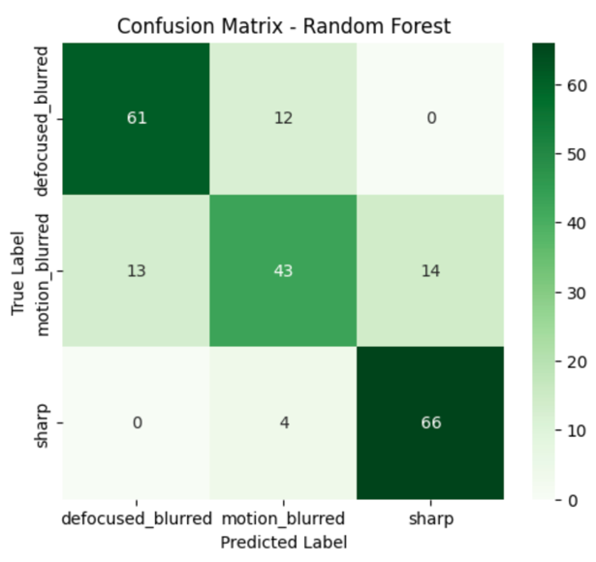

Results:
The SVM model achieved strong classification performance across all classes, especially in distinguishing sharp images from blurred ones. Random Forest also performed well but showed slightly lower consistency for motion blur detection. Confusion matrices indicate most errors occur between motion blur and defocus blur.
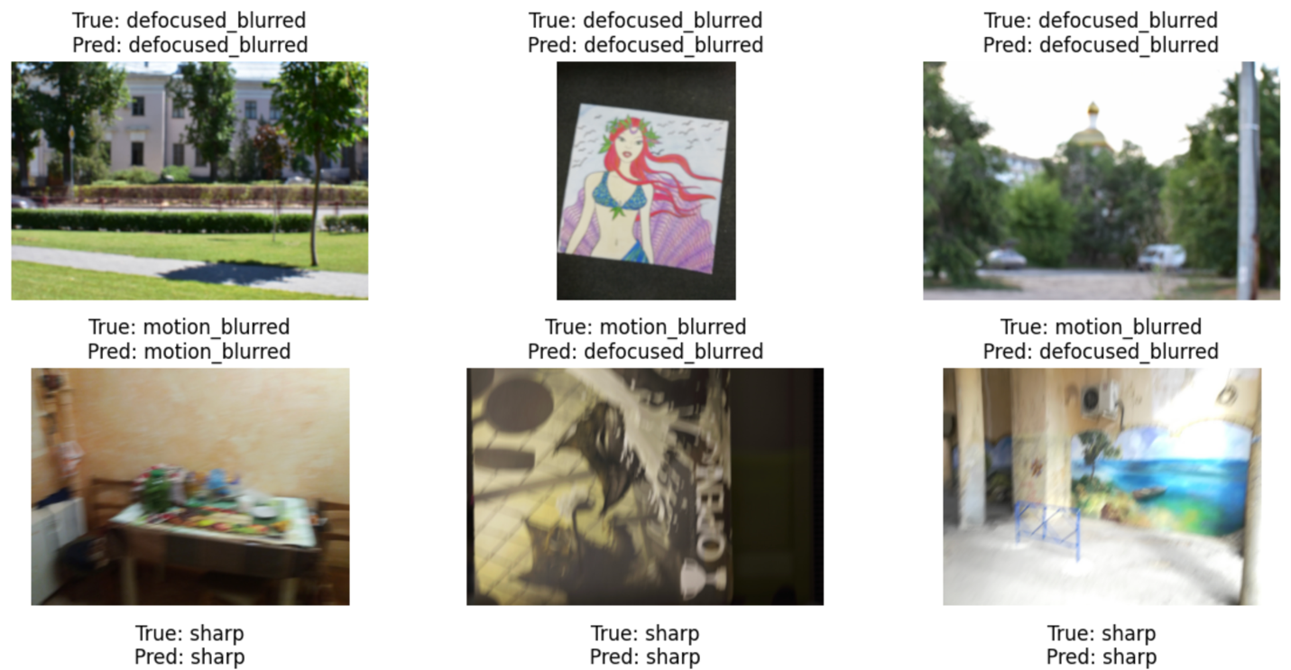

Conclusion:
This project demonstrates that classical machine learning combined with effective feature extraction can successfully detect and classify image blur. The approach is computationally efficient and suitable for real-time or resource-constrained applications. Future work may include feature expansion or hybrid deep-learning methods.

